**37**

**Diffraction Patterns and Polarization**

|  |
| --- |
| **CHAPTER OUTLINE** |

37.1 Introduction to Diffraction Patterns

37.2 Diffraction Patterns from Narrow Slits

37.3 Resolution of Single-Slit and Circular Apertures

37.4 The Diffraction Grating

37.5 Diffraction of X-Rays by Crystals

37.6 Polarization of Light Waves

* An asterisk indicates a question or problem new to this edition.

|  |
| --- |
| **ANSWERS TO THINK-PAIR-SHARE ACTIVITES** |

**\*TP 37.1 Conceptualize** The stack of polarizers will “gently” rotate the plane of polarization without losing much of the intensity, compared to a sudden rotation of 45.0° with a single polarizer. Because the angle between adjacent polarizers will be small, the intensity loss for each pair given by Malus’s law will be small.

**Categorize** This problem involves the *traveling wave* model in the special case of polarization.

**Analyze** (a) Let the angle between adjacent sheets be **. According to Malus’s law, Equation 37.9, if the first sheet is placed at angle ** with respect to the polarization of the original beam, the intensity that passes through is

 (1)

Then, the second sheet passes intensity

 (2)

Following this pattern through *n* sheets, we have

 (3)

Now, the final angle of 45.0° must be *n* times the angle between adjacent sheets, so

 (4)

Substitute Equation (4) into Equation (3):

 (5)

We want the final intensity to be 90.0% of the original, so

 (6)

This is a transcendental equation that cannot be solved algebraically. But the variable *n* is an integer. That makes the solution easily obtained with a spreadsheet, where we evaluate Equation (5) in the right-hand column for various values of *n*:

|  |  |
| --- | --- |
| *n* |  |
| 1 | 50.0% |
| 2 | 72.9% |
| 3 | 81.2% |
| 4 | 85.6% |
| 5 | 88.3% |
| 6 | 90.2% |
| 7 | 91.5% |
| 8 | 92.6% |
| 9 | 93.4% |
| 10 | 94.0% |

Therefore, we see that *n* = 6 is the smallest value of *n* that will provide 90.0% of the light to be transmitted.

(b) Then, the angle between the sheets is found from Equation (4):



**Finalize** What if your supervisor had asked for the outgoing beam to have 98.0% of the intensity of the original beam? We could extend the spreadsheet and find that we need 31 sheets! We have assumed ideal sheets, however, with the only loss in intensity being due to the rotation of the polarization. In reality, each sheet will provide reflection at its surface, will create scattering from impurities in the material, and may offer some attenuation of the intensity from other effects. With 31 sheets, these effects could become substantial, reducing the end result to less than 98%. Your supervisor has to decide how much reduction in intensity she can live with without introducing the accumulative complicating effects of many sheets.

*Answer:* (a) 6 (b) 7.50°

**\*TP 37.2** **Conceptualize** As the center polarizer is rotated, it is changing its angular relationship to *both* of the other polarizers, leading to the interesting graph in Figure TP37.2.

**Categorize** This problem involves the *traveling wave* model in the special case of polarized transverse waves.

**Analyze** (a) The key features to look at in the graph are the two angles at which the intensity goes to zero. At these angles, the axes of two of the polarizers must be perpendicular. So, at 35.0°, the central polarizer must have its axis at 90° relative to the axis of one of the other polarizers. Accordingly, one of the other polarizers must have a transmission axis at the angle



Both of these angles represent the same situation, since a rotation of a polarizer by 180° has no effect. Restricting ourselves to the range of 0–180° in the graph, let’s choose the angle as 125°. Similarly, when the middle polarizer is set at 105°, the intensity also drops to zero. From this result, we conclude that the remaining polarizer must have its transmission axis at the angle



Restricting ourselves to the range of 0–180° in the graph, let’s choose the angle as 15.0°.

(b) The intensity of light passing through the stack is given by Malus’s law:



where **2 is the angle that is being varied. If we interchange angles **1 and **3 in this equation, we have



Because cos ** = cos (–**), the previous two expressions are identical. Therefore, the intensity is the same regardless of which way the light is passing through the stack. Consequently, we cannot assign the angles found in part (a) to a specific polarizer.

**Finalize** Notice that we did not need the values of *I*/*I*max indicated in the graph. Based on the symmetry in Malus’s law, can you determine theoretically the angles at which *I*/*I*max should maximize, so that your prediction agrees with the graph?]

*Answers:* (a) 15.0°, 125° (b) no

**\*TP 37.3** **Conceptualize** Refer to Figure 37.6 for the behavior of the intensity of light from a single slit with angular position.

**Categorize** We are looking at diffraction from a single slit.

**Analyze** (a) A graph of the data appears below:

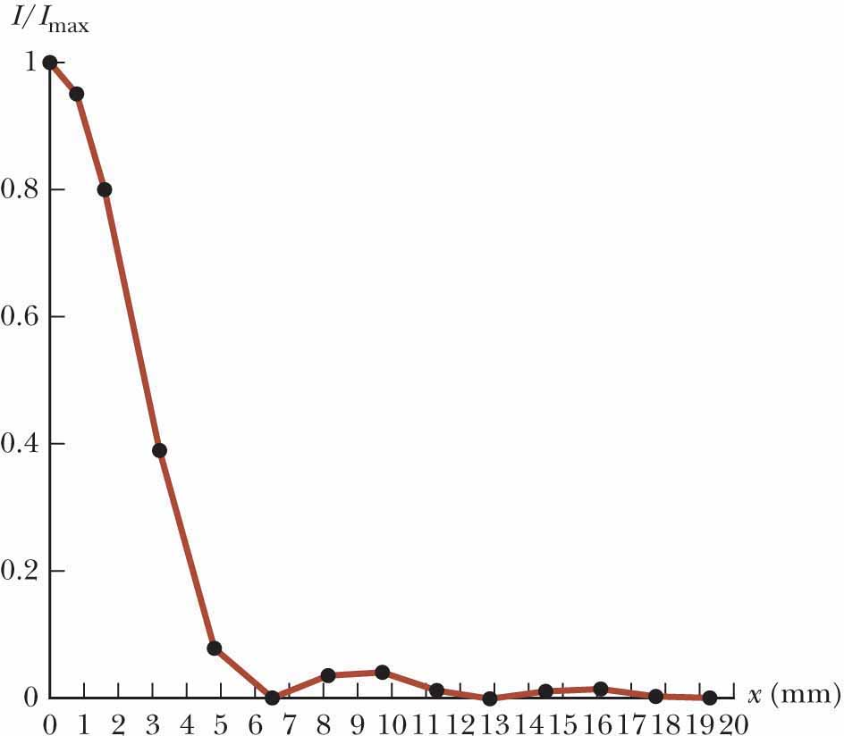

**ANS. FIG. TP37.3a**

(b) From the plot in part (a), we see that there are three identifiable minima in the intensity at the following values:

*x* = 6.5 mm, corresponding to *m* = 1

*x* = 12.9 mm, corresponding to *m* = 2

*x* = 19.3 mm, corresponding to *m* = 3

Because the distances *x* of the minima are small compared to the distance *L* to the screen, we can use a small-angle approximation:

 (1)

This approximation gives the following angles for the three minima:

 (2)

Rearrange Equation 37.1:

 (3)

Equation (3) tells us that a graph of the order number *m* versus the sine of the angles at which the intensity reaches a minimum should have a slope equal to the slit width *a*. That graph, using the sine values in Equation (2), appears below.

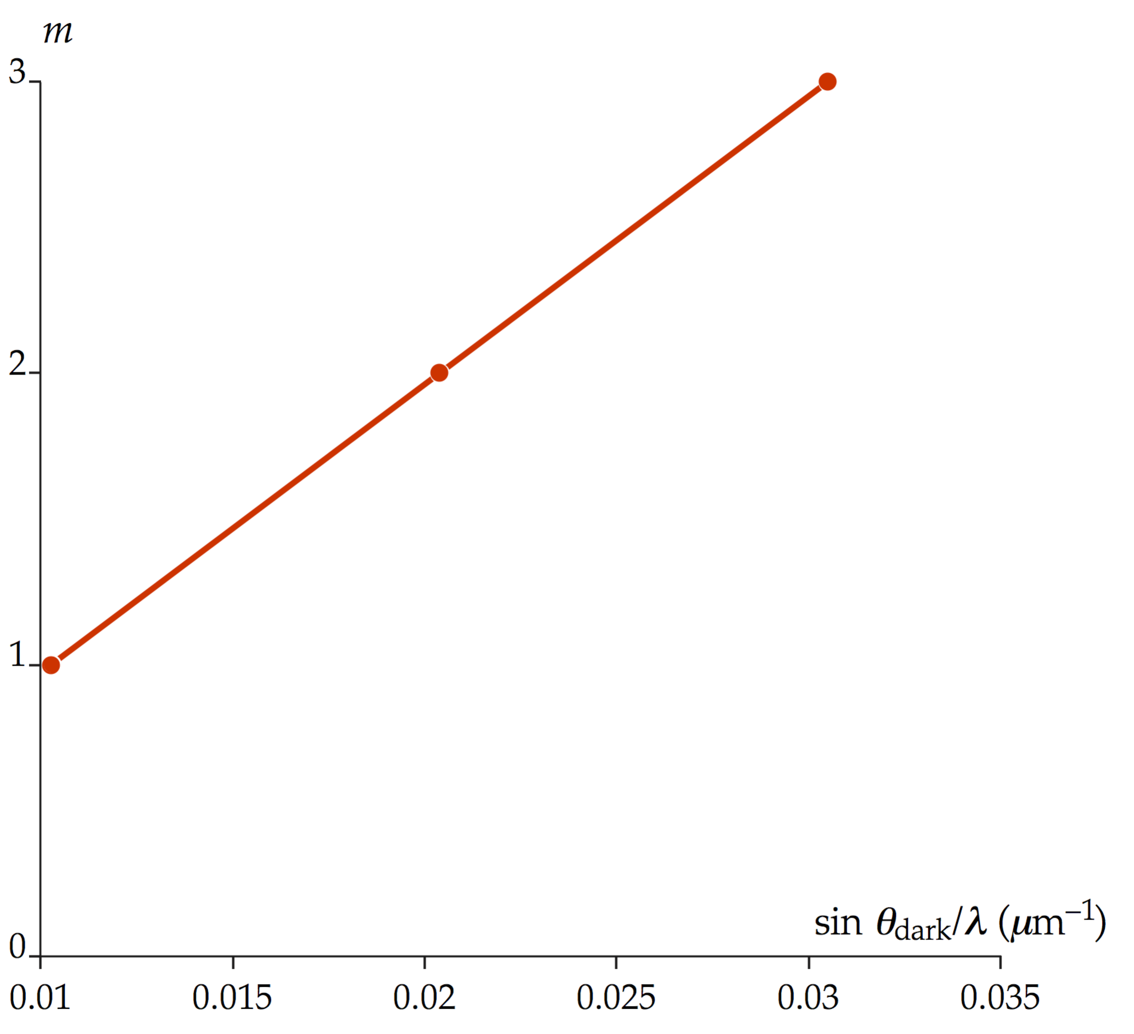

A best fit for the slope of this graph gives *a* = 99 **m.]

Answer: (a)



**ANS. FIG. TP37.3a**

(b) 99 **m

|  |
| --- |
| **SOLUTIONS TO END-OF-CHAPTER PROBLEMS** |

**Section 37.2 Diffraction Patterns from Narrow Slits**

P37.1 From Equation 37.1, with *m* = 1,



Then,



and 

**\*P37.2** **Conceptualize** Equation 37.2 gives the intensity of light for every possible angle. To find the angles at which minimum intensity occurs, we need to set the function in the brackets equal to zero.

**Categorize** The problem involves a simple manipulation of an equation in Section 37.2, so we categorize it as a substitution problem.

Begin with Equation 37.2:

 (1)

The minimum intensity of zero occurs when the function in brackets is zero, which, in turn, occurs when the numerator of this function equals zero:

 (2)

For the sine of an angle to be zero, the angle must be equal to ±*m*, where *m* is an integer. Therefore, from Equation (2),

 (3)

Equation (3) is identical to Equation 37.1.]

*Answer:* The equation generated is identical to Equation 37.1.

**P37.3** In a single slit diffraction pattern, with the slit having width *a*, the dark fringe of order *m* occurs at angle , where  and . The location, on a screen located distance *L* from the slit, of the dark fringe of order *m* (measured from *y* = 0 at the center of the central maximum) is



(a) The central maximum extends from the *m* = +1 dark fringe on one side to the *m* = –1 dark fringe on the other side, so the width of this central maximum is



Therefore,



(b) The first order bright fringe extends from the *m* = 1 dark fringe to the *m* = 2 dark fringe, or



Note that the width of the first order bright fringe is exactly one half the width of the central maximum.

**\*P37.4** **Conceptualize** Be sure you understand the discussion associated with Figure 37.7. The dashed blue curve represents the intensity of the diffraction pattern from the individual slits. By simple counting, we can see that 11 interference maxima are contained within the central diffraction maximum. We wish to show this mathematically.

**Categorize** The problem involves the *waves in interference* model in the special case of two-slit interference and diffraction from single slits.

The interference *maxima* are given by Equation 36.2:

 (1)

The diffraction *minima* are given by Equation 37.1:

 (2)

Divide Equation (1) by Equation (2):

 (3)

Because we want to know how many interference maxima are in the *central* diffraction maximum, we would like to find the value of *m*int for the first instance of a minimum in the diffraction pattern. Therefore, set *m*diff equal to 1 and set the two angles **bright and **dark equal, since we are looking at a given spot in the pattern on the screen:

 (4)

Substitute numerical values:



The value of *m*int happens to come out be an exact integer, meaning that the first diffraction minimum coincides *exactly* with the *m*int = 6 interference maximum. Therefore, the *m*int = 6 maximum is not visible. The visible maxima occur for



This is 11 possible values of *m*int, leading to 11 interference peaks contained within the central diffraction maximum.

**Finalize** Beyond the first diffraction minimum, every sixth interference maximum will be cancelled by a diffraction minimum, so each nonzero diffraction envelope outside the central maximum will contain five interference maxima.]

*Answer:* 11

**P37.5** The diffraction envelope shows a broad central maximum flanked by zeros at *a*sin*θ* = 1*λ* and *a*sin*θ* = 2*λ*. That is, the zeros are at  Noting that the distance between slits is *d* = 9 *µ*m = 3*a*, we say that within the diffraction envelope the interference pattern shows closely spaced maxima at giving  or



The third-order interference maxima are missing because they fall at the same directions as diffraction minima, but the fourth order can be visible at  as diagrammed.

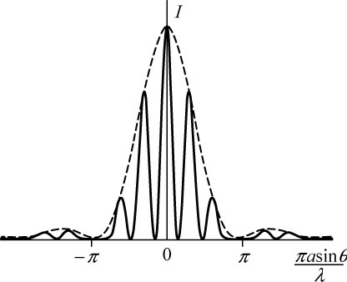

**ANS. FIG. P37.5**

**P37.6** Equation 37.1 states that , where

 The requirement for

**ANS. FIG. P37.6**

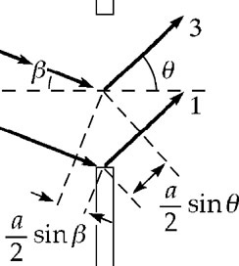

*m* = 1 is from an analysis of the extra path

distance traveled by ray 1 compared to ray 3 in the textbook Figure 37.5. This extra distance must be equal to  for destructive interference. When the source rays approach the slit at an angle *β*, there is a distance added to the path difference (of ray 1 compared to ray 3) of  Then, for destructive interference,

 so 

Dividing the slit into 4 parts leads to the second order minimum:

 so 

Dividing the slit into 6 parts gives the third order minimum:



Generalizing, we obtain the condition for the *m*th order minimum:

 

**P37.7** First we find where we are. The angle to the side is small so



The parameter controlling the intensity is



This is between 2 and 3 so the point analyzed is off in the second side fringe. The fractional intensity is



**P37.8** (a) Double-slit interference maxima are at angles given by .

For *m* = 0, 

For *m* = 1, : 

Similarly, for *m* = 2, 3, 4, and 5,



For *m* > 5, there are no maxima.

(b) Thus, there are 5 + 5 + 1 = 11 directions for interference maxima.

(c) We check for missing orders by looking for single-slit diffraction minima, at .

For *m* = 1,  and 

Thus, there is no bright fringe at this angle.

(d) From our answer to (c), two.

(e) two

(f) Two are missing because slit-slit minimum occur where a double-slit maximum would be: nine

(g) 

At *θ* = 63.6°,



and 

**Section 37.3 Resolution of Single-Slit and Circular Apertures**

**P37.9** Using Rayleigh’s criterion,  Therefore,



**P37.10** (a) The limiting angle for the resolution of the microscope is



(b) For a smaller angle of diffraction we choose the smallest visible wavelength, violet at 400 nm, to obtain



(c) The wavelength in water is shortened to its vacuum value divided by the index of refraction. The resolving power is improved, with the minimum resolvable angle becoming



Better than water for many purposes is oil immersion.

**P37.11** When the pupil is open wide, it appears that the resolving power of human vision is limited by the coarseness of light sensors on the retina. But we use Rayleigh’s criterion as a handy indicator of how good our vision might be. We are given



The smallest object the astronauts can resolve is given by Rayleigh’s criterion,  Therefore,



**P37.12** Undergoing diffraction from a circular opening, the beam spreads into a cone of half-angle



The radius of the beam ten kilometers away is, from the definition of radian measure,



and its diameter is 

**P37.13** The limit of resolution in air is



In oil, the limiting angle of resolution will be



or 

**\*P37.14 Conceptualize** Imagine a Jupiter-sized planet 4.28 light-years away. Although our own Jupiter is one of the brightest objects in our sky, we can barely resolve the planet as more than a point of light with the naked eye. Could a telescope bring such a far-away Jupiter into focus?

**Categorize** This is a substitution problem. We need to employ the information on angular resolution in Section 37.3.

Let’s first find the angle subtended by the planet:

 (1)

Now, use Equation 37.6 to find the limiting angle of resolution for each telescope, assuming the shortest wavelength of 400 nm for those telescopes using visible light:

Hubble: 

Hale: 

Keck: 

Arecibo: 

*None* of these telescopes have the resolving power to resolve the Jupiter-sized planet around the star. The closest is the Keck Telescope, but this one is still off by a factor of about 14 from the required resolution. If, instead, we try to resolve the planet–star separation, in the spirit of Pluto and Charon in Figure 37.11, then the appropriate distance in the numerator of Equation (1) would be the radius of the orbit of the planet, which could be much larger than the radius of the planet. This could increase the subtended angle in Equation (1) to a value higher than the minimum angles of resolution of the three optical telescopes. ]

*Answer:* none of them

**P37.15** When the pupil is open wide, it appears that the resolving power of human vision is limited by the coarseness of light sensors on the retina. But we use Rayleigh’s criterion as a handy indicator of how good our vision might be. According to this criterion, two dots separated center-to-center by 2.00 mm would overlap when



Thus, 

**P37.16** When the pupil is open wide, it appears that the resolving power of human vision is limited by the coarseness of light sensors on the retina. But we use Rayleigh’s criterion as a handy indicator of how good our vision might be. We take , where  is the smallest angular separation of two objects for which they are resolved by an aperture of diameter *D*, *d* is the separation of the two objects, and *L* is the maximum distance of the aperture from the two objects at which they can be resolved.

(a) Two objects can be resolved if their angular separation is greater than  Thus,  should be as small as possible. Therefore, light with the smaller of the two given wavelengths is easier to resolve, i.e., blue.

(b) 

Thus for *λ* = 640 nm, *L* = 186 m, and for *λ* = 440 nm, *L* = 271 m. The viewer with the assumed diffraction-limited vision could resolve adjacent tubes of blue in the range , but cannot resolve adjacent tubes of red in this range.

**Section 37.4 The Diffraction Grating**

**P37.17** The sound has wavelength  Each diffracted beam is described by 

The zero-order beam is at *m* = 0, *θ* = 0. The beams in the first order of interference are to the left and right at



For a second-order beam we would need



No angle, smaller or larger than 90°, has a sine greater than 1. Then a diffracted beam does not exist for the second order or any higher order. The whole answer is then:

(a) There are three beams.

(b) The beams are at 0°, +45.2°, –45.2°.

**P37.18** (a) 

 and *m* = 1: At *θ* = 10.1°, 

At *θ* = 13.7°, 

At *θ* = 14.8°, 

(b)  and  so 

Therefore, if  then  gives 

Similarly, for , and for 

**P37.19** The grating spacing is



Solving for m in Equation 38.7 gives



(a) The number of times a complete order is seen is the same as the number of orders in which the long wavelength limit is visible.



or 

(b) The highest order in which the violet end of the spectrum can be seen is:



or 

**P37.20** From Equation 37.7, 

Therefore, taking the ends of the visible spectrum to be  and , the ends of the different order spectra are defined by:

End of second order: 

Start of third order: 

Thus, it is seen that  regardless of the value of the grating spacing *d.*

P37.21 The principal maxima are defined by , where *m* = 0, 1, 2, …

For *m* = 1, 

Here, *θ* is the angle between the central (*m* = 0) and the first order   
(*m* = 1) maxima. The value of *θ* can be determined from the information given about the distance between maxima and the grating-to-screen distance:



so *θ* = 15.8° and .

The distance between grating “slits” equals the reciprocal of the number of grating lines per centimeter



The wavelength is



**P37.22** (a) The several narrow parallel slits make a diffraction grating. The zeroth- and first-order maxima are separated according to

 





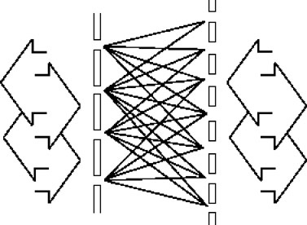

**ANS. FIG. P37.22**

(b) Many equally spaced transparent lines appear on the film. It is itself a diffraction grating. When the same light is sent through the film, it produces interference maxima separated according to





An image of the original set of slits appears on the screen. If the screen is removed, light diverges from the real images with the same wave fronts reconstructed as the original slits produced. Reasoning from the mathematics of Fourier transforms, Gabor showed that light diverging from any object, not just a set of slits, could be used. In the picture, the slits or maxima on the left are separated by 1.20 mm. The slits or maxima on the right are separated by 0.738 mm. The length difference between any pair of lines is an integer number of wavelengths. Light can be sent through equally well toward the right or toward the left.

**\*P37.23 Conceptualize** The surface of the DVD acts as a reflection grating, as discussed in Conceptual Example 37.4.

**Categorize** We model the light as *waves under reflection* and *waves in interference* in the special case of a diffraction grating.

**Analyze** The light waves from the laser pointer undergo the same type of interference as in Figure 37.12, except that that they are reflected from the grating rather than passing through the grating. We can still use Equation 37.7 to find the angles at which a bright maximum occurs:

 (1)

(a) Let’s evaluate this angle for various values of *m* starting at *m* = 1 (*m* = 0 is the normal reflection):



The calculation for the *m* = 2 bright fringe would give us



Because the values of the sine function are limited to being between –1 and +1, there is no solution to this equation. Therefore, there will be *two* maxima on the ceiling, corresponding to *m* = +1 and *m* = –1.

(b) The laser pointer in part (a) is at the red end of the spectrum. Let’s imagine using a laser pointer at the violet end with wavelength of, say, 405 nm. Can we see more maxima? Evaluate the angles again using this new wavelength:



The calculation for the *m* = 2 bright fringe would give us



No. This wavelength again gives us only two maxima, corresponding to *m* = +1 and *m* = –1. The possibilities *m* = ±2 give a result that is still not possible, although the argument of the arcsine function is very close to the range between –1 and +1 that would give an angle. Perform the calculation again assuming that the tracks on the DVD are separated by 0.820 **m. What are the results now?

**Finalize** There are no visible wavelengths of a laser pointer that will give anything other than two maxima from the DVD.]

*Answers:* (a) two, at ±52.3° (b) no

**Section 37.5 Diffraction of X-rays by Crystals**

**P37.24** From 



and 

**P37.25** (a) By Bragg’s law, , and *m* = 2:



(b) We obtain the number of orders from



The order-number must be an integer, so the largest value *m* can have is 4: four orders can be observed.

**\*P37.26 Conceptualize** Review Section 37.5 to make sure you understand x-ray diffraction from crystals. Figure 37.20 shows the NaCl crystal you are studying.

**Categorize** We use the *waves in interference* model in the special case of x-ray diffraction.

**Analyze** Equation 37.8 gives the condition for constructive interference in x-ray diffraction:

 (1)

where *d* is the separation between the reflecting planes.

(a) From Figure 37.20, we see that the distance between reflecting planes is *a*/2. Therefore,

 (2)

Substitute numerical values for the wavelength and the length *a*:



Because the sine of an angle must be between –1 and 1, we see that the only possibilities for *m* are *m* = 1, 2, 3, and 4. Therefore, we expect to see four maxima.

(b) The separation distance between these planes is one-third of the length of the body diagonal of the primitive cell:

 (3)

Substitute Equation (3) into Equation (1) and solve for sin**:

 (4)

Substitute numerical values for the wavelength and the length *a*:



Because the sine of an angle must be between –1 and 1, we see that the only possibilities for *m* are *m* = 1 and 2. Therefore, we expect to see two maxima.

**Finalize** Notice that the wavelength has an upper limit for seeing any diffraction from these particular planes. For example, for adjacent planes in Figure 37.20 there will be no constructive interference for

]

*Answers:* (a) four (b) two

**Section 37.6 Polarization of Light Waves**

**P37.27** 

**ANS. FIG. P37.27**







(a) 



(b)  

(c)  

**P37.28** In Equation 37.10, , the index of refraction *n*2 of the solid material must be larger than that of air (*n*1 = 1.00). Therefore, we must have . For this to be true, we must have , so  is not possible.

**P37.29** For the polarizing angle,



For the critical angle for total internal reflection,



Therefore,



**P37.30** For the polarizing angle,



and 

Thus, :



**\*P37.31 Conceptualize** The material in Section 37.6 under the heading “Polarization by Reflection” should be reviewed in order to understand the phenomenon in this problem.

**Categorize** We use the *wave under refraction* model in the special case of complete polarization for the wave reflected from the surface.

**Analyze** Let’s add some geometry to the figure:

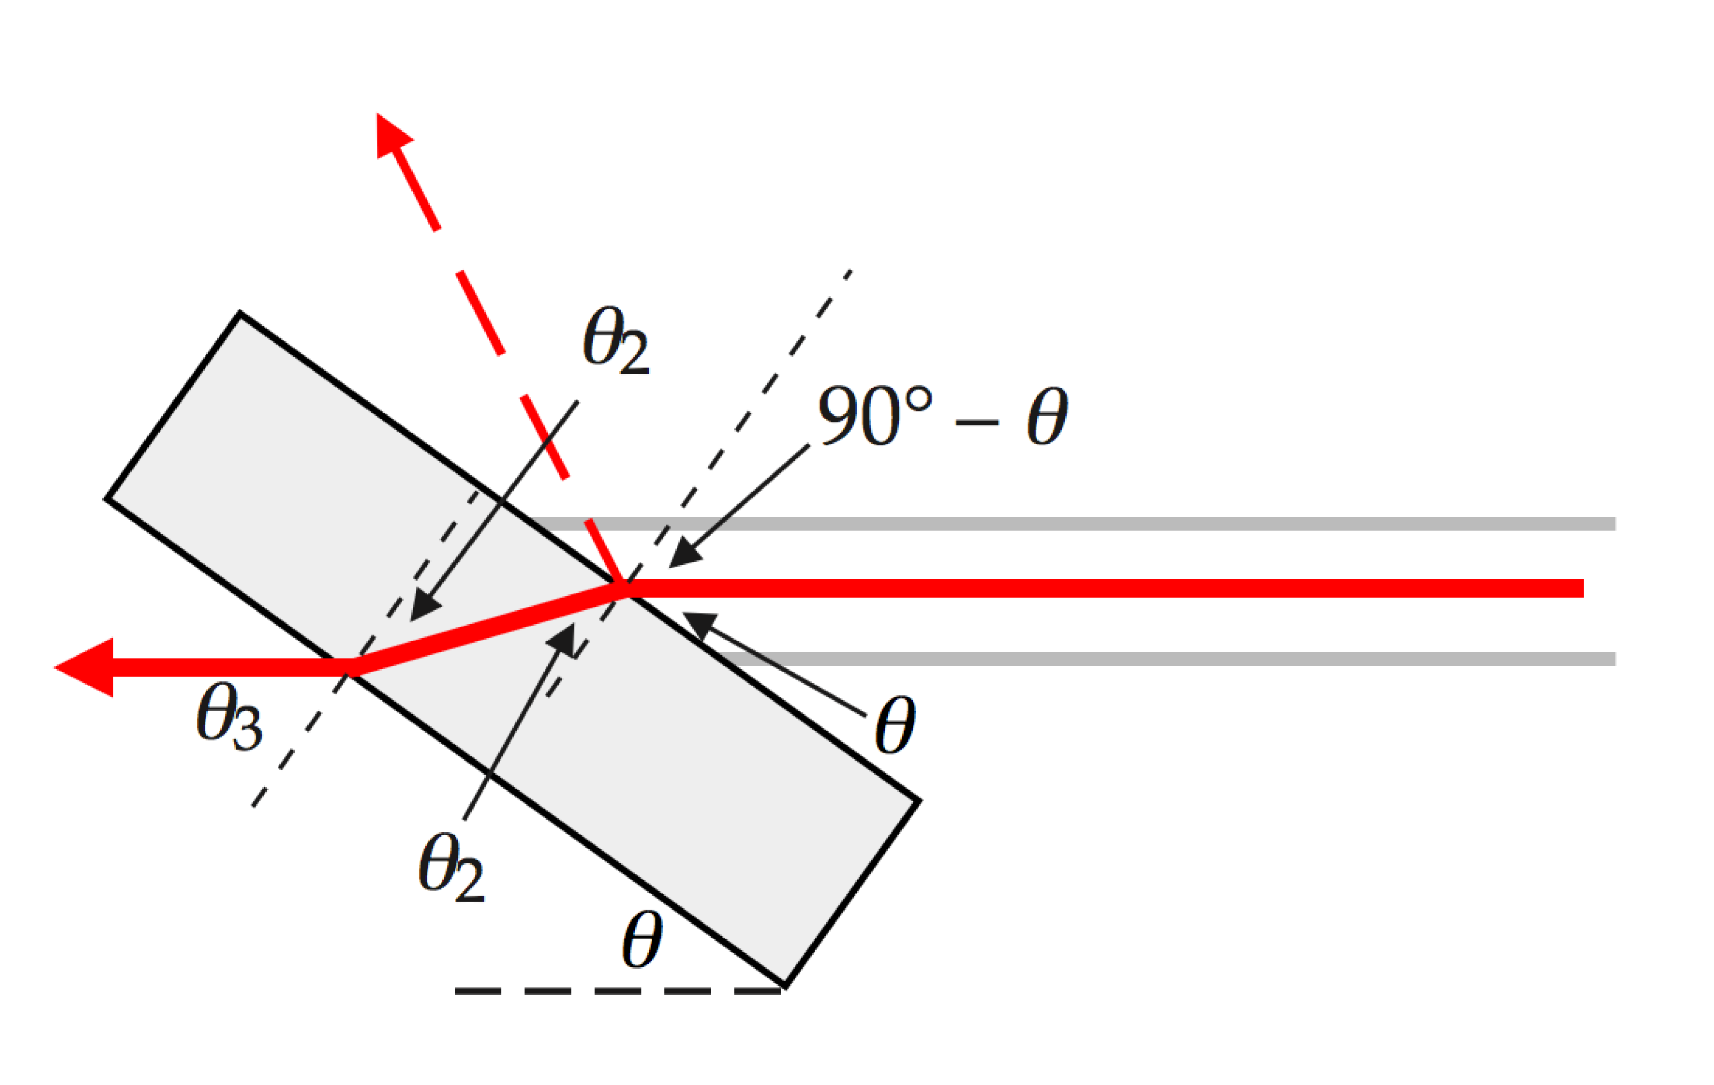

(a) In order for the reflected beam to be completely polarized, the incident beam must strike the surface at Brewster’s angle, from Equation 37.10:

 (1)

The incident angle in the diagram is **1 = 90° – θ. Therefore,

 (2)

Substitute numerical values:



(b) From Snell’s law, the angle **2 as the beam enters the material is

 (3)

Construct a triangle satisfying Equation (1) with legs *n*1 and *n*2:

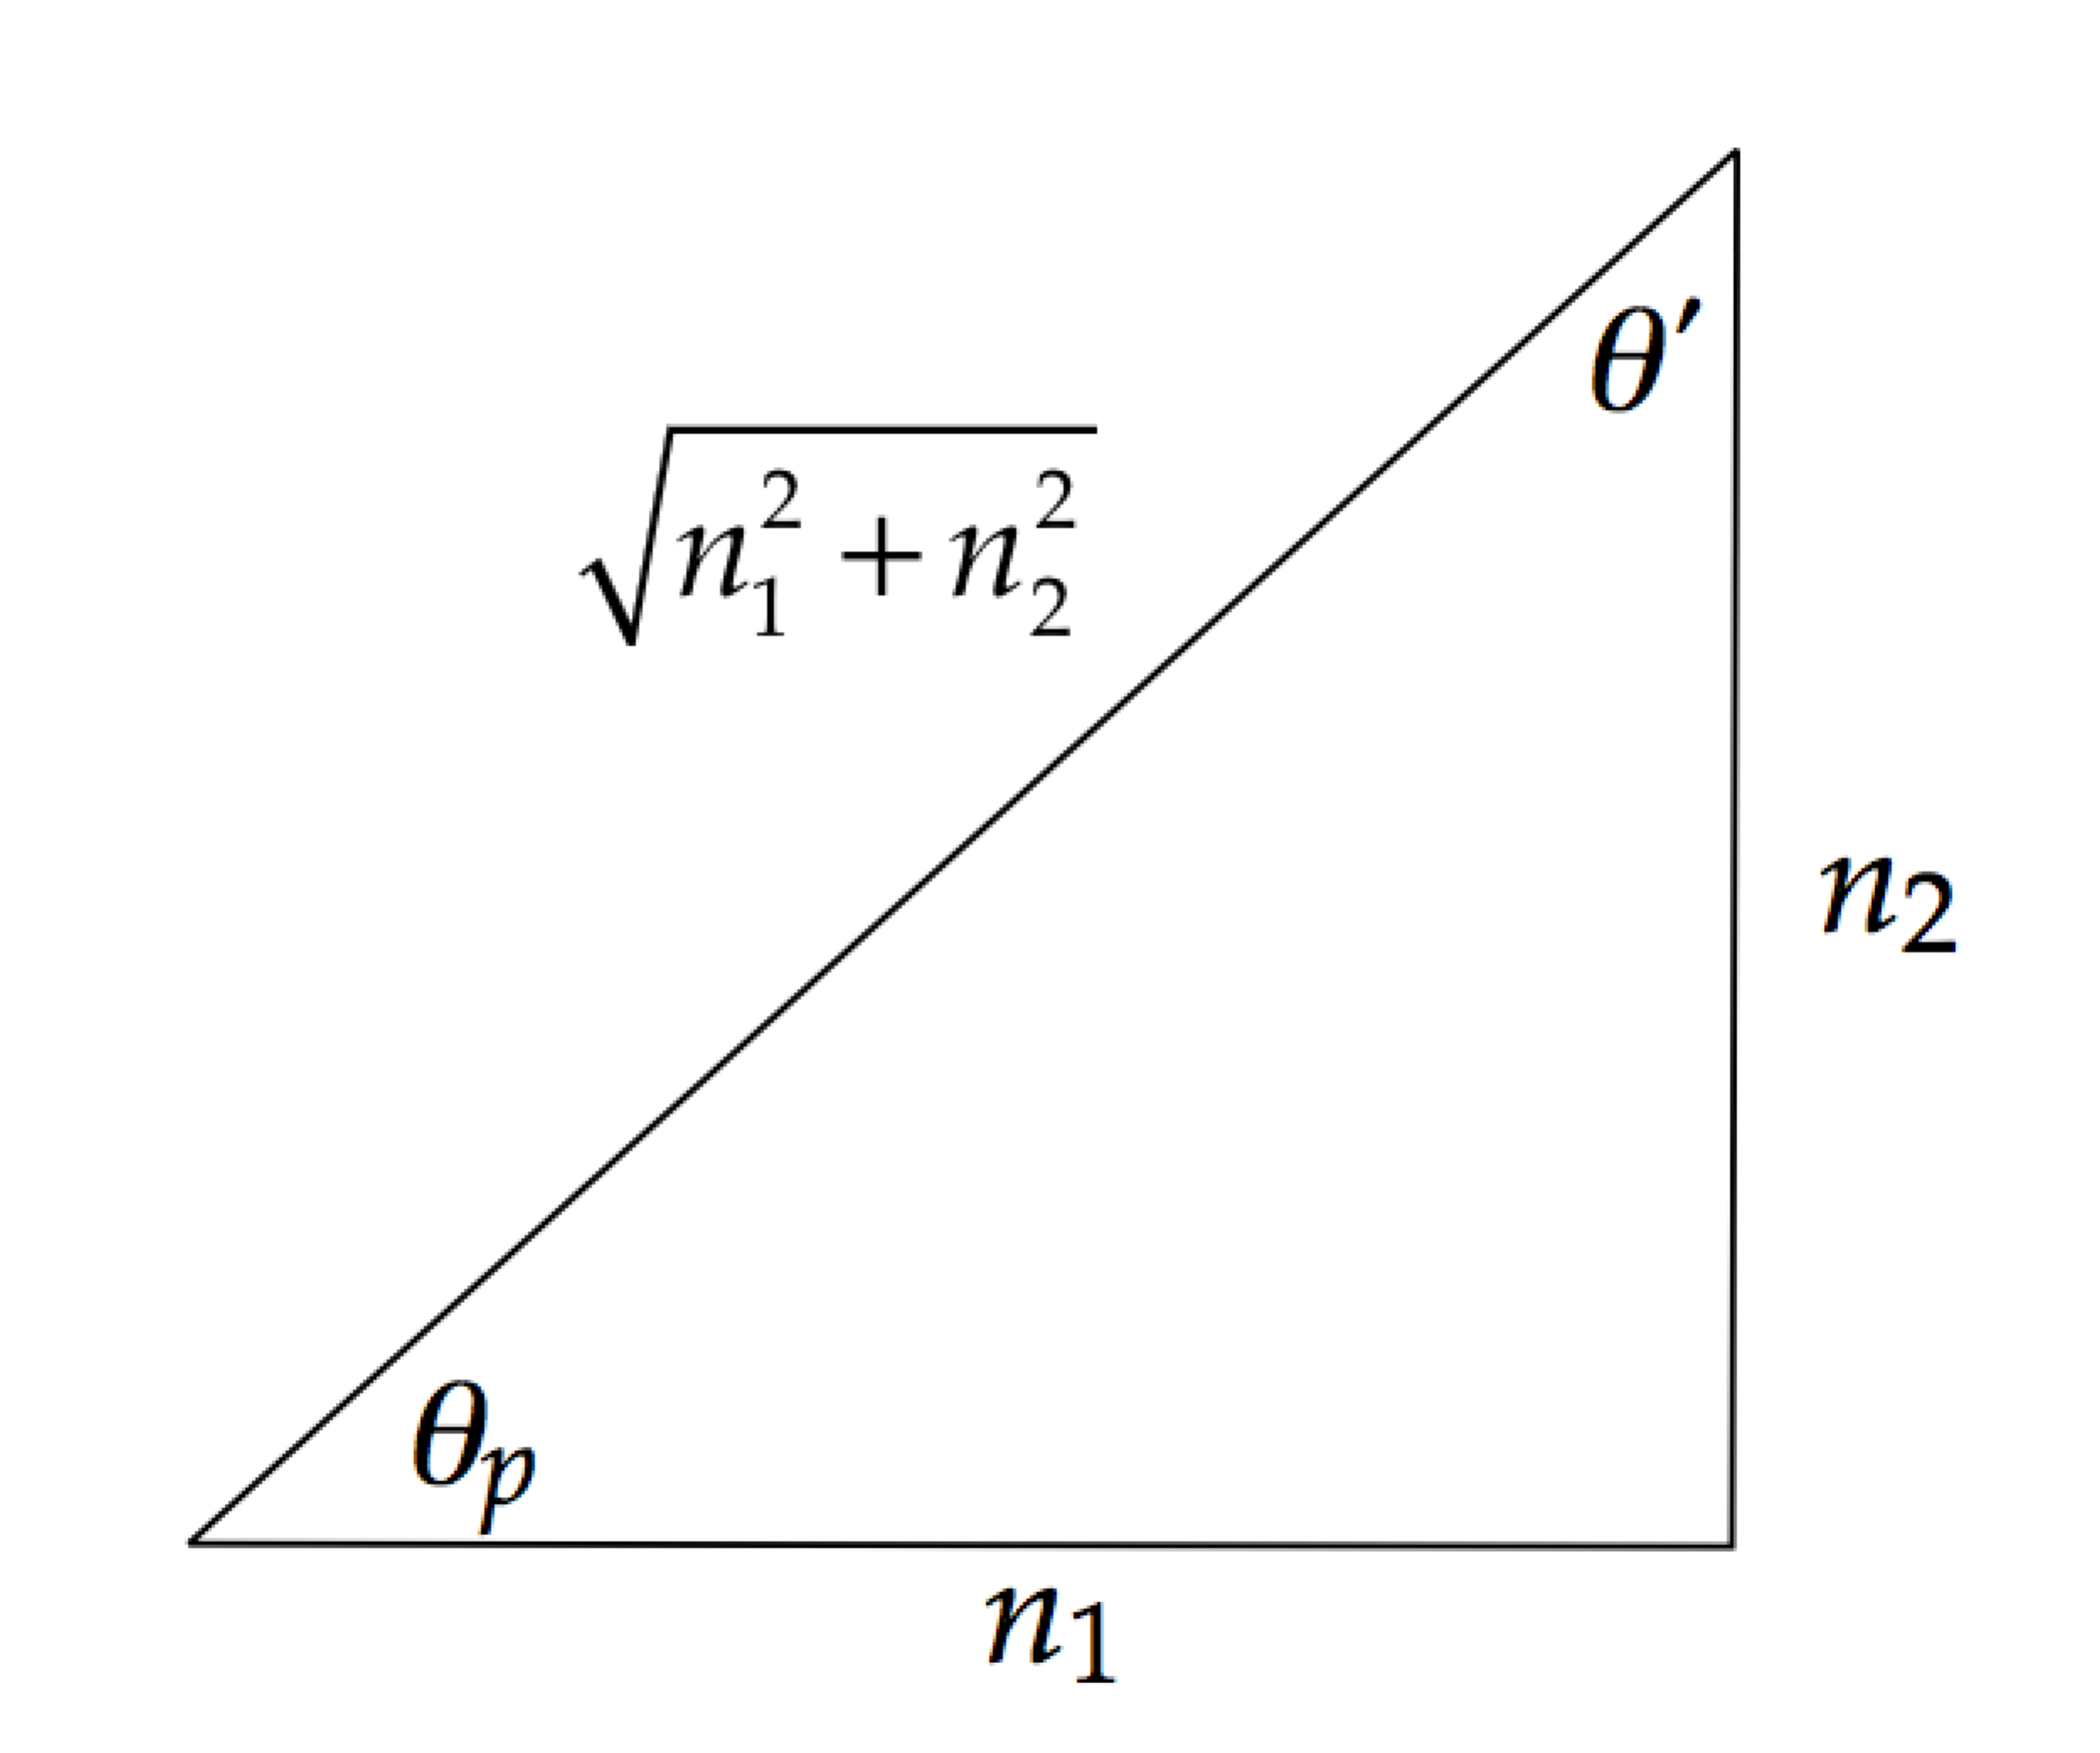

where we have used the Pythagorean theorem to find the hypotenuse. Use this triangle to modify Equation (3):

 (4)

Looking at the triangle once more, we see that

 (5)

Therefore, the incident angle of the beam on the second surface is Brewster’s angle for that surface! As a result, the desired polarization will not be reduced at the second surface. On the contrary, it will be *enhanced* due to further reflection of the part of the refracted beam that is polarized perpendicularly to the page.

**Finalize** Brewster’s windows are used widely in the laser industry to control the polarization of laser beams.]

*Answers:* (a) 20.5° (b) The refracted beam arrives at the second surface at Brewster’s angle.

**P37.32** (a) Let *I*0 represent the intensity of unpolarized light incident on the first polarizer. The intensity of unpolarized light passing through a polarizing filter is reduced by 1/2, so the first filter lets through 1/2 of the incident intensity. Of the light reaching them, the second filter passes cos2 45° = 1/2 and the third filter also   
cos2 45° = 1/2. The transmitted intensity is then



The reduction in intensity is by a factor of 1.00 – 0.125 = 0.875 of the incident intensity.

(b) By the same logic as in part (a) we have transmitted



Then the fraction absorbed is 1.00 – 0.211 = 0.789.

(c) Yet again we compute transmission



And the fraction absorbed is 1.00 – 0.330 = 0.670.

(d) 

**Additional Problems**

**P37.33** (a) We assume the first side maximum is at  (Its location is determined more precisely in Problem 47.) Then the required fractional intensity is



(b) Proceeding as in part (a), we assume 



**P37.34** (a) One slit, as the central maximum is twice as wide as the other maxima. A two-slit pattern has evenly spaced fringes (within a   
one-slit diffraction envelope).

(b) For precision, we measure from the second minimum on one side of the center to the second minimum on the other side:





**P37.35** Figure 37.21 of the text shows the situation. This is Bragg diffraction for water waves.

 or 

*m* = 1: 

*m* = 2: 

*m* = 3: 

**P37.36** (a) With light in effect moving through vacuum, Rayleigh’s criterion limits the resolution according to



The diameter of the aperture is then



(b) 

**P37.37** (a) We first determine the wavelength of 1.40-GHz radio waves from :



Applying Rayleigh’s criterion, , we obtain





(b) To determine the separation between the clouds, we use :



(c) It is not true for humans, but we assume the hawk’s visual acuity is limited only by Rayleigh’s criterion,  Substituting numerical values,



(d) Following the same procedure as in part (b), we have



**P37.38** Differentiating Equation 37.7,, gives



or 

Plugging in for 



so 

**P37.39** The grid spacing is



(a) From Equation 38.7, :



(b) In water,



and 

(c) 

Each equals 2*λ*: therefore .

**P37.40** We check to see if the *m* = 15 interference maximum is visible.

We find the sine of the angle for the *m* = *m*double two-slit interference maximum:

 **[1]**

Then find the sine of the angle for the *m* = *m*single single-slit interference minimum:

 **[2]**

Divide equation [2] by equation [1]:



Now let the angle of the single-slit minimum be equal to that of the double-slit maximum:



which gives 

Therefore, the *m*single = 1 minimum aligns with the *m*double = 15 maximum so that the *m*double = 15 maximum has zero intensity and could not startle the co-worker.

**P37.41**  In ANS. FIG. P37.41, light strikes the liquid at the polarizing angle  enters the liquid at angle , and then strikes the slab at the angle , which is equal to the polarizing angle  The angle between the water surface and the surface of the slab, *θ*, is related to the other angles by (from the triangle)



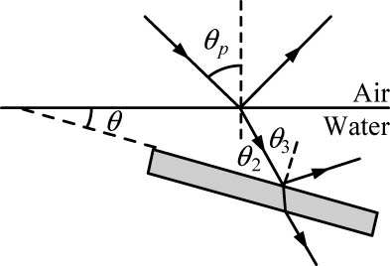

**ANS. FIG. P37.41**

For the air-to-water interface,



and 



For the water-to-slab interface,



The angle between surfaces is 

**P37.42** Refer to ANS. FIG. P37.41 above. Light strikes the liquid at the polarizing angle  enters the liquid at angle , and then strikes the slab at the angle , which is equal to the polarizing angle . The angle between the water surface and the surface of the slab, *θ*, is related to the other angles by (from the triangle)



Also,



For the air-to-liquid interface,



So, 

For the water-to-slab interface,



Therefore,



**P37.43** (a) We require



Then, 

(b) 

**P37.44** (a) Bragg’s law applies to the space lattice of melanin rods. Consider the planes *d* = 0.25 *µ*m apart. For light at near-normal incidence, strong reflection happens for the wavelength given by  The longest wavelength reflected strongly corresponds to *m* = 1:



This is the blue-green color.

(b) For light incident at grazing angle 60°,  gives  This is violet.

(c) Your two eyes receive light reflected from the feather at different angles, so they receive light incident at different angles and containing different colors reinforced by constructive interference.

(d) The longest wavelength that can be reflected with extra strength by these melanin rods is the one we computed first, 500 nm blue-green.

(e) If the melanin rods were farther apart (say 0.32 *µ*m) they could reflect red with constructive interference.

**P37.45** (a) Constructive interference of light of wavelength *λ* on the screen is described by  and, because , we may write . Therefore,



Differentiating with respect to *y* gives



(b) Here  gives, for *m* = 1,



or 

Then,



So we have



**P37.46** (a) Applying Snell’s law gives . From the sketch in ANS. FIG. P37.46(a), we also see that:

ANS. FIG. P37.46(a)

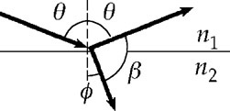

, or 

Using the given identity,



which reduces to,



Applying the identity again,



Snell’s law then becomes,



or (after dividing by cos*θ*):



Solving for tan*θ* gives:



(b) If , the above result becomes:

, which is Brewster’s law

**P37.47** From  we find



and require that it be zero. The possibility  locates all of the minima and the central maximum, according to

; ;



The side maxima are found from



This has solutions

*φ* = 4.493 4, *φ* = 7.7253, and others.

(a) *φ* = 4.49 compared to the prediction from the approximation of   
1.5*π* = 4.71.

(b) *φ* = 7.73 compared to the prediction from the approximation of   
2.5*π* = 7.85.

**P37.48** (a) From Equation 37.2,  where we define .

Therefore, when  we must have

, or 

(b) Let  and .

A plot of *y*1 and *y*2 in the range  is shown in ANS. FIG. P37.48(b).

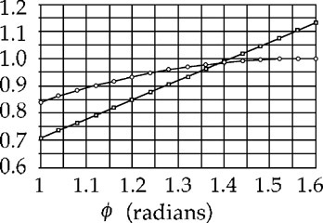

**ANS. FIG. P37.48 (b)**

The solution to the transcendental equation is found to be .

(c)  gives . If  is small, then .

This gives the half-width, measured away from the maximum at *θ* = 0. The pattern is symmetric, so the full width is given by



(d)

|  |  |  |
| --- | --- | --- |
| *φ* |  |  |
| 1 | 1.19 | bigger than *φ* |
| 2 | 1.29 | smaller than *φ* |
| 1.5 | 1.41 | smaller |
| 1.4 | 1.394 |  |
| 1.39 | 1.391 | bigger |
| 1.395 | 1.392 |  |
| 1.392 | 1.391 7 | smaller |
| 1.391 5 | 1.391 54 | bigger |
| 1.391 52 | 1.391 55 | bigger |
| 1.391 6 | 1.391 568 | smaller |
| 1.391 58 | 1.391 563 |  |
| 1.391 57 | 1.391 561 |  |
| 1.391 56 | 1.391 558 |  |
| 1.391 559 | 1.391 557 8 |  |
| 1.391 558 | 1.391 557 5 |  |
| 1.391 557 | 1.391 557 3 |  |
| 1.391 557 4 | 1.391 557 4 |  |

We get the answer as 1.391 557 4 to seven digits after 17 steps. Clever guessing, like using the value of  as the next guess for *φ*, could reduce this to around 13 steps.

**P37.49** (a) The angles of bright beams diffracted from the grating are given by  The angular dispersion is defined as the derivative :



(b) For the average wavelength



 gives



and 

The separation angle between the lines is, for



and



**Challenge Problems**

**P37.50** (a) The concave mirror of the spy satellite is probably about 2 m in diameter, and is surely not more than 5 m in diameter. That is the size of the largest piece of glass successfully cast to a precise shape, for the mirror of the Hale telescope on Mount Palomar. If the spy satellite had a larger mirror, its manufacture could not be kept secret, and it would be visible from the ground. Outer space is probably closer than your state capitol, but the satellite is surely above 200-km altitude, for reasonably low air friction. We find the distance between barely resolvable objects at a distance of 200 km, seen in yellow light through a 5-m aperture:



Thus the snooping spy satellite cannot see the difference between III and II or IV on a license plate. A resolution of about 3 cm would make it difficult to read a license plate.

(b) No. The resolution is too large. It cannot count coins spilled on a sidewalk, much less read the dates on them.

Considering atmospheric image distortion caused by variations in air density and temperature, the distance between barely resolvable objects is more like, assuming a limiting angle of one second of arc,



P37.51 (a) The *E* and *O* rays, in phase at the surface of the plate, will have a phase difference



after traveling distance *d* through the plate. Here *δ* is the difference in the *optical path* lengths of these rays. The optical path length between two points is the product of the actual path length *d* and the index of refraction. Therefore,



The absolute value is used since  may be more or less than unity. Therefore,



(b) 

**P37.52** For incident unpolarized light of intensity *I*max, the average value of the cosine-squared function is one-half, so the intensity after transmission by the first disk is 

After transmitting 2nd disk: 

After transmitting 3rd disk: 

where the angle between the first and second disk is .

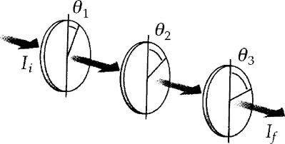

**ANS. FIG. P37.52**

Using trigonometric identities 

and 

we have 



Since  the intensity of the emerging beam is given by



**P37.53** The energy in the central maximum we can estimate in Figure P37.53 as proportional to



As in Problem P37.47, the maximum height of the first side maximum is approximately



Then the energy in one side maximum is proportional to , and that in both of the first side maxima together is proportional to .

Similarly and more precisely, and always with the same proportionality constant, the energy in both of the second side maxima is proportional to .

The energy in all of the side maxima together is proportional to



The ratio of the energy in the central maximum to the total energy is then



Our calculation is only a rough estimate, because the shape of the central maximum in particular is not just a vertically-stretched cycle of a cosine curve. It is slimmer than that

|  |
| --- |
| **ANSWERS TO QUICK-QUIZZES** |

1. (a)

2. (b)

**3.** (a)

**4.** (c)

**5.** (b)

**6.** (c)

|  |
| --- |
| **ANSWERS TO EVEN-NUMBERED PROBLEMS** |

**P37.2** The equation generated is identical to Equation 37.1

**P37.4** 11

**P37.6** See P37.6 for full explanation.

**P37.8** (a) , , , , , ;  
(b) 11, (c) , (d) two, (e) two, (f) nine, (g) 0.032 4*I*max

**P37.10** (a) 79.8 *µ*rad; (b) violet, 54.2 *µ*rad; (c) The resolving power is improved, with the minimum resolvable angle becoming 60.0 *µ*rad.

**P37.12** 3.09 m

**P37.14** none of them

**P37.16** (a) Blue; (b) 186 m to 271 m

**P37.18** (a) 479 nm, 647 nm, 698 nm; (b) 20.5°, 28.3°, 30.7°

**P37.20**  and these orders must overlap.

**P37.22** (a) 0.738 mm; (b) See P37.22(b) for full explanation.

**P37.24** *θ* = 31.9°

**P37.26** (a) four (b) two

**P37.28** See P37.28 for full explanation.

**P37.30**  or  or 

**P37.32** (a) 0.875; (b) 0.789; (c) 0.670; (d) We can get more and more of the incident light through the stack of ideal filters, approaching 50%, by reducing the angle between the transmission axes of each one and next.

**P37.34** (a) One slit, as the central maximum is twice as wide as the other maxima; (b) 0.122 mm wide

**P37.36** (a) 5.63 mm; (b) The assumption is unreasonable. Over a horizontal path of 12 km in air, density variation associated with convection would make the motorcycles completely unresolvable with any optical device.

**P37.38** See P37.38 for full explanation.

**P37.40** See P37.40 for full explanation.

**P37.42** 

**P37.44** (a–e) See P37.44 for full explanations.

**P37.46** (a) ; (b) See P37.46(b) for full explanation.

**P37.48** (a) ; (b) *φ* = 1.39 rad; (c) ; (d) 17 steps (13 with clever guessing)

**P37.50** (a) A resolution of about 3 cm would make it difficult to read a license plate; (b) No

**P37.52** 